**Mozambique country profile**

Published

17 January

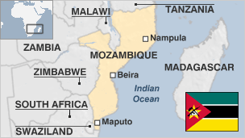

**Mozambique, which gained independence from Portugal in 1975, is still suffering from the effects of a 16-year civil war that ended in 1992.**

Tensions remain between the ruling Frelimo party and the opposition former rebel movement Renamo and corruption has become a major concern.

The discovery of gas fields off Mozambique's coast in 2011 is set to transform the economy of one of Africa's poorest nations.

But despite recent economic growth, more than half of Mozambique's 24 million people continue to live below the poverty line.

* Read more [country profiles](http://news.bbc.co.uk/1/hi/country_profiles/) - Profiles by [BBC Monitoring](http://bbc.co.uk/monitoring)

**President: Filipe Nyusi**

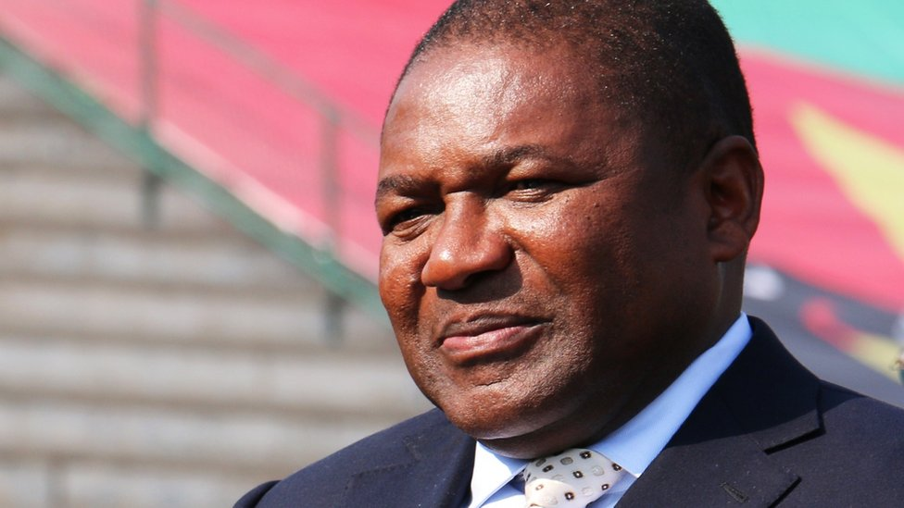image copyrightGetty Images

Filipe Nyusi, of the ruling party Frelimo party, was sworn in as president in January 2015, and was inaurugated for a final five-year term in 2020.

Two months later he succeeded former president Armando Guebuza as party leader, representing a change in guard in Frelimo, which has dominated politics in Mozambique since it won independence from Portugal in 1975.

During his election campaign, Mr Nyusi pledged to transform Mozambique, one of Africa's poorest nations.

He presides over a country on the cusp of tapping newly discovered offshore gas fields that could transform Mozambique's economy, although an Islamist insurgency in the far north has raised questions about the state's ability to guarantee security.

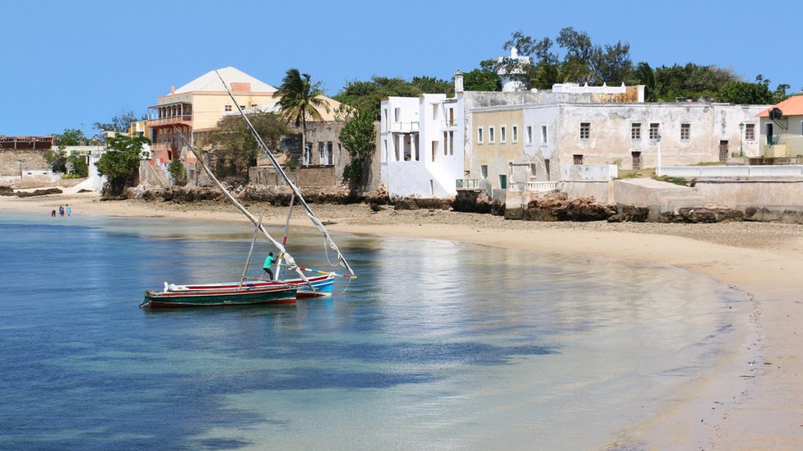image copyrightGetty Images

image captionMozambique has several Indian Ocean islands that attract tourists

Television is a key medium. State-run radio operates alongside private FM stations.

Print media have limited influence.

Journalists who upset the authorities risk intimidation and threats and self-censorship is commonplace, says Reporters Without Borders.

# Mozambique profile - Timeline

Published

19 March 2019

## A chronology of key events:

**3rd century** - Iron Age Bantu-speaking tribes move into area from west-central Africa.

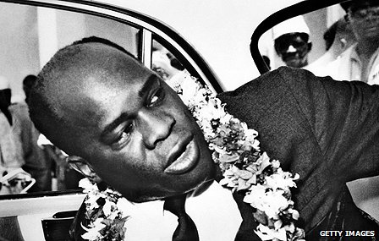image copyrightGetty Images

image captionEduardo Mondlane led the Frelimo independence movement which eventually took over from the Portuguese colonists

**11th century** - Shona empire develops between Limpopo and Zambezi rivers.

**1498** - Portuguese expedition led by explorer Vasco da Gama drops anchor off Mozambican coast.

**16-17th centuries** - Portuguese venture into interior. Following military campaigns, colonists set up trading posts and mining enterprises and parcel-out land to European settlers.

**18th-19th centuries** - Mozambique becomes major slave-trading centre.

## Slave trade banned

**1842** - Portugal outlaws slave trade from Mozambique, but clandestine trade continues for decades.

**1878** - Portugal leases large tracts of territory to trading companies, who use conscript African labour to further their interests and build infrastructure.

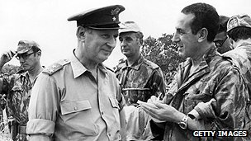image copyrightGetty Images

image captionThe Portuguese military battled against a relatively small guerrilla force fighting for independence

**1932** - Portugal breaks up trading companies and imposes direct rule over colony.

**1950s-60s** - Colonial economy thrives, attracting thousands of Portuguese settlers.

**1962** - Exiled activists form Mozambique Liberation Front - Frelimo - headed by Eduardo Mondlane.

**1964** - Frelimo forces begin war of independence. Guerrilla tactics frustrate Portuguese and Frelimo take control of much of north.

**1974** - Military coup in Portugal, new government agrees independence with Frelimo. More than 250,000 Portuguese inhabitants leave.

## Independence

**1975** - Mozambique becomes independent under Frelimo one-party rule of President Samora Machel.

**1976** - Renamo anti-Frelimo group aided by Rhodesia and later South Africa.

**1977** - Frelimo adopts Marxist-Leninism.

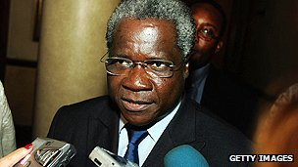image copyrightGetty Images

image captionAfonso Dhaklama led the rebel group Renamo whose campaign destabilised the country for decades

**1986** - President Machel is killed in an air crash. Joaquim Chissano becomes president.

**1989** - Frelimo renounces Marxist-Leninism as Soviet power collapses.

## Multi-party politics

**1990** - Government amends the constitution to allow a multi-party political system.

**1992** - President Chissano and Renamo leader Afonso Dhaklama sign peace deal in Rome.

**1995** - Mozambique joins Commonwealth.

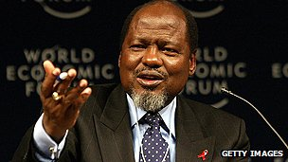image copyrightGetty Images

image captionJoaquim Chissano served as president for two terms

**2005** February - Frelimo's Armando Guebuza inaugurated as president after defeating Afonso Dhlakama in November presidential poll.

**2006** July - The World Bank cancels most of Mozambique's debt under a plan promoted by the G8 nations.

**2011** October - Italian energy company Eni says it's made a giant gas discovery off the coast of Cabo Delgado Province in the north.

**2014** January - Hundreds flee renewed fighting between government forces and Renamo rebels in the south district of Homoine.

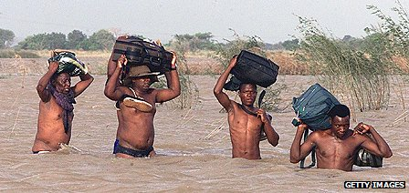image copyrightGetty Images

image captionMozambique has suffered flooding several times, including in 2000

**2014** October - The ruling Frelimo party and its candidate Filipe Nyusi win presidential and legislative elections after Renamo signs truce.

**2017** January-August - President Nyusi and Renamo leader Dhlakama finally end conflict.

## Northern insurgency

**2017** November - Jihadist insurgency begins in Cabo Delgado Province in the north.

**2019** March - Cyclone Idai causes extensive flooding and loss of life in Sofala Province.

**2020** January - President Nyusi inaugurated after winning re-election for final five-year term.